SUNDAY | MONDAY | TUESDAY | WEDNESDAY | THURSDAY | FRIDAY | SATURDAY
1 | 2  HAPPY  LABOUR  DAY!  Labour Day in Canada is celebrated on the first Monday of September. It originally gave workers the chance to campaign for better working conditions or pay. The day is now part of a long weekend for many Canadians. | 3  9:45 Bible Study (LIB)  9:45 What’s Up In Rec? (G)  10:00 LIBRARY CART WITH PAM (W)  10:45 Get To Know You (G)  11:00 Get To Know You (B)  12:30 OUTING TO BLACKFOOT TRUCK STOP (TW)  1:00 Get To Know You (H)  3:45 Crib Club (TW)  4:00 Ladder Ball (LIB)  4:00 Walk & Talk (GC)  6:30 SING N’ BE HAPPY (TW) | 4  10:00 ANGLICAN CHURCH SERVICE (TW)  10:00 What’s Up In Rec? (R)  11:00 Flower Arranging (TW)  11:00 Heighten Your Senses (H)  1:15 Shuffleboard (TW)  1:30 Brain Games (FL)  1:30 Music Therapy Visits (W)  2:00 Closed Music Therapy Session R/B (LIB)  2:15 Shuffleboard (TW)  3:00 Get To Know You (R)  4:00 Fella-Ship Club (LIB)  6:30 Music Appreciation (TW) | 5  9:45 CATHOLIC MASS (TW)  9:45 Get A Move On (LIB)  10:00 Alive Inside (R/B)  11:00 News & Views (LIB)  11:00 What’s Up In Rec? (H)  1:30- 2:30 CYCLING WITHOUT AGE (GC)  1:30 ICE CREAM WITH A VIEW OUTING (TW)  1:30 Card Bingo (TW)  2:45 Artist’s Corner (TW)  3:30 Get To Know You (G)  4:00 Trivial Pursuit (LIB)  4:00 Walk & Talk (GC)  6:30 Carpet Bowling (TW) | 6  9:45 Painting (TW)  10:30 Java Music Club (LIB)  10:45 Get A Move On (R/B)  11:00 Get To Know You (H)  11:30 What’s Up In Rec? (B)  11:45 Shoe Shine (W)  1:00- 2:00 CYCLING WITHOUT AGE (GC)  2:30 GRANDPARENTS DAY CELEBRATION (TW)  4:00 Sing with Me (TW) | 7  9:30 Ladder Ball (TW)  9:45 Music Appreciation (LIB)  11:00 How Is It Spelled? (LIB)  1:00-2:00 CYCLING WITHOUT AGE (GC)  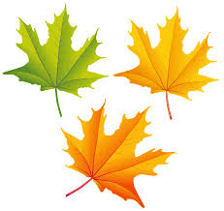  2:30 Horse Races (TW)
8  John O.  Betty J.  Evelyn H.  Glennys P.  Irene P.  John W.  Lucy M.  Doris S.  Gary P.  Irene P.  Liz M. | 9  10:00 Get To Know You (B)  10:30 Get A Move On (TW)  1:15 Beach Ball Toss (GC/TW)  1:30- 2:30 CYCLING WITHOUT AGE (GC)  2:30 WELCOME AND BIRTHDAY PARTY WITH  DAIGA & ANNA (DR)  4:00 Get To Know You (G)  4:00 Trivial Pursuit (LIB)  6:30 Shuffleboard (TW) | 10  9:45 Ball Toss (R)  9:45 Bible Study (LIB)  10:00 SHOPPING OUTING TO SOUTHCENTRE MALL (TW)  10:45 Brain Games (H)  11:00 How Is It Spelled? (LIB)  1:00 Get To Know You (H)  1:30-2:30 CYCLING WITHOUT AGE (GC)  2:15 Artist’s Corner (TW)  4:00 Crib Club (TW)  4:00 Ladder Ball (LIB)  6:30 SING N’ BE HAPPY WITH LARRY (TW) | 11  11:00 Flower Arranging (TW)  11:00 Heighten Your Senses (G)  1:15 Shuffleboard (TW)  1:30-2:30 CYCLING WITHOUT AGE (GC)  1:30 Music Therapy Visits (W)  2:00 Closed Music Therapy Session R/B (LIB)  2:15 Shuffleboard (TW)  3:00 Get To Know You (R)  4:00 Fella-Ship Club (LIB)  6:30 Music Appreciation (TW)  THIS CALENDAR IS SUBJECT TO CHANGE… PLEASE REFER TO DAILY PROGRAM BOARDS ON EACH WING. | 12  9:45 CATHOLIC MASS (TW)  9:45 Get A Move On (LIB)  10:00 Taboo (FL)  11:00 How Is It Spelled? (LIB)  11:00 Get To Know You (G)  1:00 OUTING TO SASKATOON BERRY FARM (TW)  1:30- 2:30 CYCLING WITHOUT AGE (GC)  1:30 Bingo (TW)  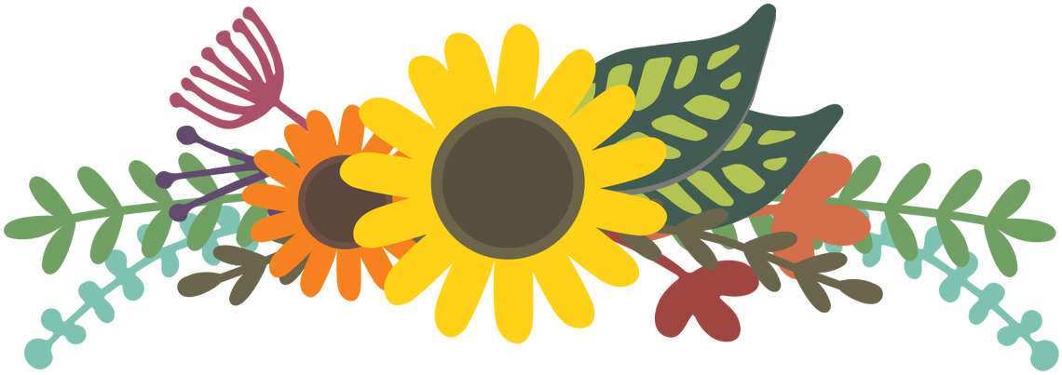  6:30 PET PALS VISIT (TW) | 13  9:45 Painting (TW)  10:30 Java Music Club  (LIB)  10:45 Alive Inside (W)  10:45 Get A Move On (R/B)  11:45 Connect 4 (R)  1:15 Brain Games (LIB)  1:30 Heighten your Senses (W)  1:30- 2:30 CYCLING WITHOUT AGE (GC)  2:30 ICE CREAM FLOATS (TW)  3:00 Get To Know You (G)  4:00 Sing With Me (LIB) | 14  9:30 Card Club (TW)  9:45 Get A Move On (LIB)  11:00 How Is It Spelled? (LIB)  11:00-12:00 CYCLING WITHOUT AGE (GC)  2:30 Karaoke with Jess & Ken (TW)

SUNDAY | MONDAY | TUESDAY | WEDNESDAY | THURSDAY | FRIDAY | SATURDAY
15 | 16  10:00 Get To Know You (B)  10:30 Get A Move On (LIB)  10:30 ERNA PLAYS CLASSICAL PIANO (TW)  1:00 Get To Know You (G)  1:15 Balloon Badminton (GC/TW)  2:00 Remember When (LIB)  2:15 Mandala Coloring (FL)  2:30 Heighten Your Senses (R)  4:00 Trivial Pursuit (LIB)  6:30 Shuffleboard (TW) | 17  9:45 Bible Study (LIB)  9:45 Ball Toss (B)  10:00 LIBRARY CART WITH PAM (W)  10:00 Baking (TW)  10:45 OUTING TO SWISS CHALET (TW)  11:00 Alive Inside (W)  1:00 Get To Know You (H)  1:30-2:30 CYCLING WITHOUT AGE (GC)  4:00 Crib Club (TW)  4:00 Ladder Ball (LIB)  6:30 SING N’ BE HAPPY (TW) | 18  11:00 Flower Arranging (TW)  11:00 Heighten Your Senses (R)  1:15 Shuffleboard (TW)  1:30-2:30 CYCLING WITHOUT AGE (GC)  1:30 Music Therapy Visits (W)  2:00 Closed Music Therapy Session R/B (LIB)  2:15 Shuffleboard (TW)  3:00 Get To Know You (R)  4:00 Fella-Ship Club (LIB)  6:30 Music Appreciation (LIB) | 19  9:45 CATHOLIC MASS (TW)  9:45 Get A Move On (LIB)  10:00 Alive Inside (R/B)  10:00 Taboo (FL)  11:00 News & Views (LIB)  1:15 OUTING TO TOP DOGS (TW)  1:30-2:30 CYCLING WITHOUT AGE (GC)  1:30 Card Bingo (TW)  2:45 Artist’s Corner (TW)  3:30 Get To Know You (G)  4:00 Trivial Pursuit (LIB)  4:00 Walk & Talk (GC)  6:30 Carpet Bowling (TW) | 20  9:45 Painting (TW)  9:45 Alive Inside (W)  10:30 Java Music Club (LIB)  10:45 Get A Move On (R/B)  11:00 Get To Know You (R)  11:45 Connect 4 (R)  1:15 News & Views (LIB)  1:30- 2:30 CYCLING WITHOUT AGE (GC)  1:30 Heighten Your Senses (W)  2:30 FALL TEA PARTY (TW)  4:00 Sing With Me (LIB) | 21  9:30 Chair Yoga (TW)  9:45 Sing with Me (LIB)  11:00 Word Games (LIB)  11:00- 12:00 CYCLING WITHOUT AGE (GC)  2:30 Create & Construct (TW)
22  2:00  CHURCH OF GOD OF PHROPHECY  CHURCH  SERVICE  (TW) | 23  10:00 Get To Know You (B)  10:30 Get A Move On (TW)  1:30- 2:30 CYCLING WITHOUT AGE (GC)  2:30 RON MARIER ENTERTAINS (DR)  2:30 Heighten Your Senses (B)  3:45 Remember When (LIB)  4:00 Get To Know You (G)  4:00 Trivial Pursuit (LIB)  6:30 Shuffleboard (TW) | 24  9:45 Bible Study (LIB)  9:45 Ball Toss (R)  10:45 OUTING TO OLIVE GARDEN (TW)  1:00 Get To Know You (H)  1:30-2:30 CYCLING WITHOUT AGE (GC)  3:45 Crib Club (TW)  4:00 Walk & Talk (GC)  4:30 Ladder Ball (LIB)  6:30 SING N’ BE HAPPY WITH LARRY (TW) | 25  11:00 Flower Arranging (TW)  11:00 Heighten Your Senses (B)  1:15 Shuffleboard (TW)  1:30-2:30 CYCLING WITHOUT AGE (GC)  1:30 Music Therapy Visits  (H/G)  2:00 Closed Music Therapy Session R/B (LIB)  2:15 Shuffleboard (TW)  3:00 Get To Know You (R)  4:00 Fella-Ship Club (LIB)  6:30 Music Appreciation (LIB) | 26  9:45 CATHOLIC MASS (TW)  9:45 Get A Move On (LIB)  10:00 Taboo (FL)  11:00 Shoe Shine (W)  11:00 Get To Know You (G)  1:00-2:00 CYCLING WITHOUT AGE (GC)  2:30 TROPICAL ARMCHAIR TRAVEL TO HAWAII (TW)  4:00 Trivial Pursuit (LIB)  6:30 Carpet Bowling (TW) | 27  9:45 Fact or Fiction (W)  9:45 Painting (TW)  10:30 Java Music Club (LIB)  10:45 Alive Inside (R/B)  1:15 Brain Games (LIB)  1:30- 2:30 CYCLING WITHOUT AGE (GC)  1:30 Connect 4 (W)  2:30 Walk & Talk (GC)  3:00 Get To Know You  (B)  4:00 Sing With Me (LIB) | 28  9:30 Balloon Badminton (TW)  9:45 Get A Move On (LIB)  11:00 Trivial Pursuit (LIB)  11:00- 12:00 CYCLING WITHOUT AGE (GC)  2:30 Tea Party (TW)
29  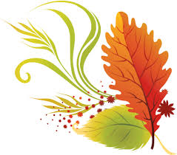 | 30  9:45 RESIDENT & FAMILY COUNCIL MEETING (LIB)  10:30 Get A Move On (TW)  11:00 Get To Know You (B)  1:15 Balloon Badminton (GC/TW)  1:30- 2:30 CYCLING WITHOUT AGE (GC)  2:30 Heighten Your Senses (H)  4:00 Get To Know You (G)  4:00 Trivial Pursuit (LIB)  6:30 SHUFFLEBOARD WITH RAYMOND ON PIANO (TW) | 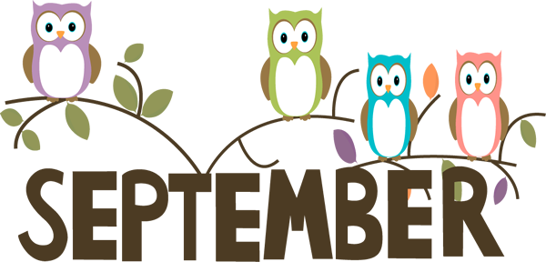 |  |  |  | ROOM LEGEND:  (B) BRITANNIA  (DR) DINING ROOM  (FL) FRONT LOUNGE  (FP) FRONT PATIO  (G) GLENMORE  (GC) GARDEN COURT  (H) HERITAGE  (LIB) LIBRARY  (R) RIDEAU  (TW) THERAPY WING  (W) WINGS

