SUNDAY | MONDAY | TUESDAY | WEDNESDAY | THURSDAY | FRIDAY | SATURDAY
ROOM LEGEND:  (W) WINGS  (B) BRITANNIA  (FL) FRONT LOUNGE  (FP) FRONT PATIO  (G) GLENMORE  (GC) GARDEN COURT  (H) HERITAGE  (LIB) LIBRARY  (R) RIDEAU  (TW) THERAPY WING | 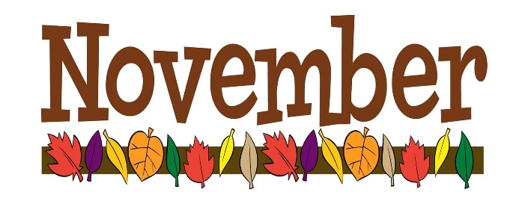 |  |  | 1  9:45 CATHOLIC MASS (TW)  10:15 OUTING TO LUNCHBOX THEATRE  “BRAVE GIRL” (FL)  1:30 Card Bingo (TW)  2:15 Strathcona Students Pick (TW)  4:00 Brain Games (LIB)  6:30 Sing N’ Be Happy (TW)  TODAY WE WELCOME DANIELLE, OUR NEW RECREATION THERAPIST TO THE RECREATION DEPARTMENT! | 2  9:45 Painting (TW)  10:30 Java Music Club (LIB)  10:45 Good Ol’ Days (FL)  11:45 Connect 4 (R)  2:30 REMEMBRANCE DAY TEA GATHERING! (TW) | 3  8:00 Men’s Breakfast Club (TW)  10:30 Shuffleboard (TW)  1:30 Trivial Pursuit (LIB)
4  2:30  ST. ANDREW’S UNITED CHRUCH SERVICE  (TW) | 5  11:00 Get To Know You (R)  11:00 News & Views (H)  12:30 LIBRARY CART WITH PAM (W)  1:30 Let’s Get A Move On (LIB)  2:30 WELCOME & BIRTHDAY PARTY WITH RANDY POIRIER (DR)  6:30 Shuffleboard (TW) | 6  9:15 Get To Know You (H)  10:30 REMEMBERANCE DAY SERVICE PRESENTED BY THE LEGION (TW)  1:30 Ball Toss (G)  2:00 Let’s Chat (FL)  2:15 Who Am I ? (LIB)  3:45 Crib Club (TW)  6:30 SING ALONG WITH RAYMOND AND LARRY (TW) | 7  10:00 ANGLICAN CHURCH SERVICE (TW)  10:00 Let’s Chat (H)  10:30 Balloon Badminton (B)  10:45 News & Views (G)  11:15 Good Ol’ Days (R)  12:30-3:00 POSSIBLE YES OR NO VOTE FOR CALGARY HOSTING 2026 WINTER OLYMPICS (LIB)  1:15 Shuffleboard (TW)  1:30 Music Therapy Visits (W)  2:15 Shuffleboard (TW) | 8  9:45 CATHOLIC MASS (TW)  10:45 OUTING TO RED LOBSTER (TW)  2:00 Beach Ball Volleyball (TW)  4:00 This Day In History (FL)  4:00 What Am I? (LIB)  6:30 Sing N’ Be Happy (TW) | 9  9:45 Painting (TW)  10:30 Java Music Club (LIB)  11:45 Connect 4 (R)  2:30 ICE CREAM PARLOUR (TW)  2:30 Chair Yoga (LIB) | 10  8:00 Women’s Breakfast Club (TW)  10:30 Trivial Pursuit/Brain Games (LIB)  1:30 Noodle Ball (TW)

THIS CALENDAR IS SUBJECT TO CHANGE… PLEASE REFER TO DAILY PROGRAMS LOCATED ON THE WINGS.

SUNDAY | MONDAY | TUESDAY | WEDNESDAY | THURSDAY | FRIDAY | SATURDAY
11  TODAY IS  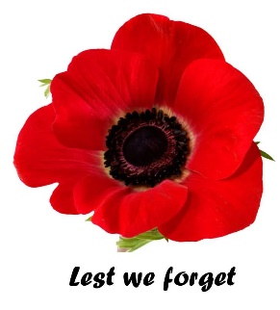  REMEMBRANCE DAY! | 12  9:00 Let’s Get A Move On (TW)  11:00 News and Views (LIB)  2:00 Shuffleboard (TW)  4:00 Get To Know You (R) | 13  9:45 Creative Movement (R)  10:30 Ball Toss (G)  11:00 Get To Know You (H)  12:45 OUTING TO CENTURY BOWLING (TW)  2:00 Baking (TW)  2:15 Trivial Pursuit (LIB)  3:45 Crib Club (TW)  6:30 SING ALONG WITH RAYMOND AND LARRY (TW) | 14  9:45 Connect 4 (R)  10:15 Carpet Bowling (TW)  10:30 Good Ol’ Days (FL)  10:45 Brain Games (LIB)  1:15 Shuffleboard (TW)  1:30 Music Therapy Visits (W)  2:30 HAPPY GANG CHOIR (DR) | 15  9:45 CATHOLIC MASS (TW)  10:45 LUNCH OUTING TO THE OLD SPAGHETTI FACTORY (TW)  1:30 Card Club (TW)  2:15 Strathcona Students Pick (TW)  4:00 Math Quiz (LIB)  6:30 Sing N’ Be Happy (TW) | 16  9:45 Painting (TW)  10:30 Java Music Club (LIB)  11:45 Connect 4 (R)  3:00 BERNADETTE  ENETERTAINS DURING TEA TIME (DR) | 17
18  2:00  CHURCH OF GOD  CHURCH  SERVICE  (TW) | 19  10:00 LIBRARY CART WITH PAM (W)  11:00 News & Views (H)  1:45 Let’s Get A Move On (LIB)  2:45 Creative Expressions (TW)  6:30 SING ALONG WITH RAYMOND AND LARRY (TW) | 20 HAPPY INTERNATIONAL  CHILDREN’S DAY  9:45 Creative Movement (LIB)  10:30 Ball Toss (G)  11:00 Get To Know You (H)  12:45 OUTING TO THE DEERFOOT INN CASINO (TW)  2:15 Sing With Me (LIB) | 21  10:15 Carpet Bowling (LIB)  1:15 Shuffleboard (TW)  1:30 Music Therapy Visits (H/G)  2:00 Closed Music Therapy Session R/B (LIB)  2:15 Shuffleboard (TW) | 22  9:45 CATHOLIC MASS (TW)  10:45 TIM HORTONS GET TOGETHER (TW)  1:30 Card Bingo (TW)  2:15 Strathcona Students Pick (TW)  2:30 How’s It Spelled? (LIB)  4:00 Bible Study (LIB)  6:30 Sing N’ Be Happy (TW) | 23  9:45 Painting (TW)  10:30 Java Music Club (LIB)  11:45 Connect 4 (R)  2:30 RICK KELLY ENTERTAINS (TW) | 24
25  2:00  ST. PETER’S ANGLICAN  CHURCH  SERVICE  (TW) | 26  9:45 RESIDENT & FAMILY COUNCIL MEETING (LIB)  11:00 News & Views (H)  1:45 Let’s Get A Move On (LIB)  2:45 Creative Expressions (TW)  4:00 Get To Know You (R)  6:30 SING ALONG WITH RAYMOND AND LARRY (TW) | 27  9:45 Creative Movement (LIB)  9:45 SHOPPING AT SOUTH CENTRE MALL (TW)  11:00 Get To Know You (H)  2:00 Let’s Chat (FL)  2:15 Music Appreciation (TW)  3:45 Crib Club (TW)  6:30 Shuffleboard (TW) | 28  10:15 Carpet Bowling (TW)  1:15 Shuffleboard (TW)  1:30 Music Therapy Visits (H/G)  2:00 Closed Music Therapy Session R/B (LIB)  2:15 Good Ol’ Days (FL)  2:15 Shuffleboard (TW) | 29  9:45 CATHOLIC MASS (TW)  10:45 LUNCH OUTING TO  A&W (TW)  1:30 Card Club (TW)  2:15 Strathcona Students Pick (TW)  2:30 Popular Sayings (LIB)  4:00 Bible Study (LIB)  6:30 Sing N’ Be Happy (TW) | 30  9:45 Painting (TW)  10:30 Java Music Club (LIB)  10:45 Let’s Chat (FL)  11:45 Connect 4 (R)  2:15 ERNA PLAYS PIANO (TW)  2:30 Rhythm Band (LIB)

