THIS CALENDAR IS SUBJECT TO CHANGE…PLEASE REFER TO DAILY PROGRAM BOARDS ON EACH WING.
SUNDAY | MONDAY | TUESDAY | WEDNESDAY | THURSDAY | FRIDAY | SATURDAY
ROOM LEGEND:  (B) BRITANNIA  (DR) DINING ROOM  (FL) FRONT LOUNGE  (FP) FRONT PATIO  (G) GLENMORE  (GC) GARDEN COURT  (H) HERITAGE  (LIB) LIBRARY  (R) RIDEAU  (TW) THERAPY WING  (W) WINGS | 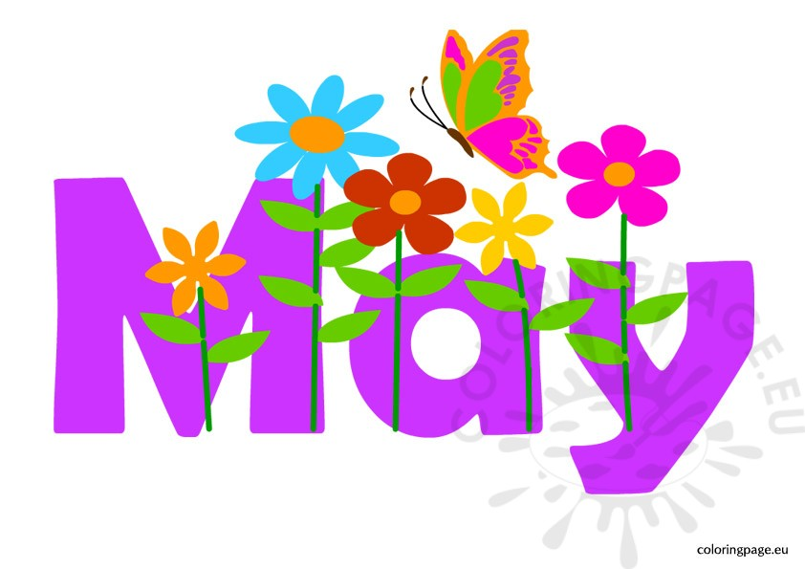 |  | 1  10:00 ANGLICAN CHURCH SERVICE (TW)  11:00 Flower Arranging (TW)  1:15 Shuffleboard (TW)  1:30 Music Therapy Visits (W)  1:30 Get To Know You (H)  2:00 Get To Know You (R)  2:00 Closed Music Therapy Session R/B (LIB)  2:15 Shuffleboard (TW)  4:00 Fella-Ship Club (LIB)  6:30 Jeopardy (TW) | 2  9:45 CATHOLIC MASS (TW)  9:45 Get A Move On (LIB)  10:00 Ball Toss (R/B)  10:00 Alive Inside (B)  11:00 Get To Know You (G)  11:15 Connect 4 (R)  1:15 OUTING TO CAT CAFÉ (TW)  1:30 Card Bingo (TW) | 3  9:45 Painting (TW)  10:30 Java Music Club (LIB)  11:45 What Am I? (B)  2:30 SPRING IN YOUR STEP DANCE WITH THE  RECREATION TEAM (TW) | 4  9:45 Music Appreciation (LIB)  11:00 Trivial Pursuit (LIB)  2:00 Bean Bag Toss (TW)
5  HAPPY | 6  9:45 CHILDREN’S VISIT (TW)  1:30 Get A Move On (LIB)  2:30 WELCOME AND BIRTHDAY PARTY WITH RON MARIER (DR)  4:00 Get To Know You (B)  6:30 SING N’ BE HAPPY WITH LARRY (TW) | 7  9:45 Bible Study (LIB)  10:00 Create & Construct (TW)  10:30 Artist’s Corner (TW)  1:15 OUTING TO MY FAVORITE ICE CREAM SHOPPE (TW)  1:30 Ladder Ball (LIB)  4:00 Crib Club (TW)  4:00 News & Views (LIB)  6:30 Sing N’ Be Happy (TW) | 8  9:30 Flower Arranging (TW)  10:30 Range of Motion (B)  1:30 Shuffleboard (TW)  1:30 Music Therapy Visits (W)  1:30 Get To Know You (H)  2:00 Get To Know You (R)  2:00 Closed Music Therapy Session R/B (LIB)  2:15 Shuffleboard (TW)  2:30 Mandala Coloring (FL)  3:00 BERNADETTE ENTERTAINS (DR)  4:00 Fella-Ship Club (LIB)  6:30 Price Is Right (TW) | 9  9:45 CATHOLIC MASS (TW)  9:45 Get A Move On (LIB)  10:00 Who Am I? (R)  10:45 Rhythm Band (LIB)  11:00 Get To Know You (G)  11:15 Balloon Badminton (B)  1:30 MANICURE OUTING (FL)  1:30 Carpet Bowling (TW) | 10  9:45 Painting (TW)  10:00 Trivial Pursuit (FL)  10:30 Java Music Club (LIB)  2:30 MOTHER’S DAY CELEBRATION (TW)  4:00 News & Views (LIB)  4:15 Good Vibes (G) | 11  9:45 Get A Move On (TW)  9:45 Sing With Me (LIB)  11:00 How Is It Spelled? (LIB)  2:00 Bingo Bash (TW)
SUNDAY | MONDAY | TUESDAY | WEDNESDAY | THURSDAY | FRIDAY | SATURDAY
12  2:30  ST. ANDREW’S UNITED  CHURCH  SERVICE  (TW) | 13  11:00 Rhythm Band (LIB)  1:45 Get A Move On (LIB)  2:15 PICTUNARY WITH  RUTH FERGUSON (TW)  2:30 Get To Know You (B)  6:30 Shuffleboard (TW) | 14  9:45 Bible Study (LIB)  9:45 Good Vibes (W)  10:00 LIBRARY CART WITH PAM (W)  10:00 Brain Games (TW)  10:45 LUNCH OUTING TO SWISS CHALET (TW)  1:30 Balloon Badminton (TW)  1:30 Fabulous Nails (G)  4:00 Heighten Your Senses (R/B)  4:00 Crib Club (FL)  4:00 Mandala Coloring (FL)  6:30 Sing N’ Be Happy (TW) | 15  10:30 Range of Motion (R)  11:00 Flower Arranging (TW)  1:15 Shuffleboard (TW)  1:30 Music Therapy Visits (W)  1:30 Get To Know You (H)  2:00 Closed Music Therapy Session R/B (LIB)  2:15 Shuffleboard (TW)  4:00 Fella-Ship Club (LIB)  6:30 Family Feud (TW) | 16  9:30 Ball Toss (R/B)  9:45 CATHOLIC MASS (TW)  9:45 Get A Move On (LIB)  10:45 LUNCH OUTING TO OLIVE GARDEN (TW)  11:00 Get To Know You (G)  1:45 Bingo (TW)  2:00 Alive Inside (R/B)  3:45 Board Games (FL) | 17  9:45 Painting (TW)  10:30 News & Views (LIB)  11:45 Ball Toss (B)  1:00 Good Vibes (G)  2:30 ICE CREAM FLOAT EXTRAVAGANZA (TW) | 18  9:45 Sing with Me (TW)  11:00 Brain Games (LIB)  2:00 Bean Bag Toss (TW)
19 | 20  HAPPY  VICTORIA  DAY  EVERYONE! | 21  9:45 Bible Study (LIB)  10:00 Create & Construct (TW)  10:45 LUNCH OUTING TO SPOLUMBOS (TW)  1:30 Ladder Ball (LIB)  1:30 Baking (TW)  2:45 Woodworking (TW)  3:45 Crib Club (FL)  3:45 Artist’s Corner (TW)  4:00 News & Views (LIB)  6:30 SING N’ BE HAPPY WITH LARRY (TW) | 22  10:30 Range of Motion (B)  11:00 Flower Arranging (TW)  1:15 Shuffleboard (TW)  1:30 Music Therapy Visits  (H/G)  1:30 Get To Know You (H)  2:00 Get To Know You (R)  2:00 Closed Music Therapy Session R/B (LIB)  2:15 Shuffleboard (TW)  2:30 Alive Inside (W)  6:30 Jeopardy (TW) | 23  9:45 CATHOLIC MASS (TW)  9:45 Get A Move On (LIB)  9:45 Get to Know You (B)  10:00 What Am I? (B)  10:45 Rhythm Band (LIB)  11:00 Get To Know You (G)  11:15 Connect 4 (R)  1:30 Card Bingo (TW)  1:30 OUTING TO CENTURY BOWLING (FL) | 24  9:45 CHILDREN’S VISIT (TW)  10:00 Trivial Pursuit (FL)  10:15 Java Music Club (LIB)  11:00-2:00  MAYFAIR GARDEN PARTY (GC)  4:00 Mandala Coloring (FL) | 25  9:45 Get A Move On (TW)  11:00 How Is It Spelled? (LIB)  2:00 Tea Party (TW)
26  2:00  CHURCH OF  GOD  CHURCH  SERVICE  (TW) | 27  9:45 RESIDENT & FAMILY COUNCIL MEETING (LIB)  1:45 Get A Move On (LIB)  2:30 Get To Know You (B)  2:45 Artist's Corner (TW)  3:00 BERNADETTE ENTERTAINS (DR)  6:30 SING ALONG WITH RAYMOND AND BRAIN GAMES (TW) | 28  9:45 Bible Study (LIB)  9:45 Good Vibes (W)  10:00 LIBRARY CART WITH PAM (W)  10:45 LUNCH OUTING TO THE LODGE IN DEERFOOT CITY MALL FOODCOURT (TW)  3:45 Heighten Your Senses (R/B)  3:45 Crib Club (TW)  6:30 Sing N’ Be Happy (TW) | 29  10:30 Range of Motion (R)  11:00 Flower Arranging (TW)  1:15 Shuffleboard (TW)  1:30 Music Therapy Visits  (H/G)  2:00 Get To Know You (R)  2:00 Closed Music Therapy Session R/B (LIB)  2:15 Shuffleboard (TW) | 30  9:45 CATHOLIC MASS (TW)  9:45 Get A Move On (LIB)  10:00 OUTING TO INGLEWOOD BIRD SANCTUARY (FL)  11:00 Get To Know You (G)  1:30 Balloon Volleyball/  Noodle Ball (TW)  3:00 Alive Inside (R/B) | 31  9:45 CHILDREN’S VISIT (TW)  10:30 Java Music Club (LIB)  11:45 Balloon Badminton (R)  2:30 CRAIG AND ANGIE WEST ENTERTAIN (TW) | HAPPY BIRTHDAY TO…  LEONA DERRY  MARIA WETSCH  JOSEPH LaPOINTE  SHIRLEY SIBLEY  BETSY BARRY  FRANCES WALKER  FRAN KILLIAN  BARRIE BANKS  LIL CAPPER  IVANKA PREPOLEC

