THIS CALENDAR IS SUBJECT TO CHANGE.
SUNDAY | MONDAY | TUESDAY | WEDNESDAY | THURSDAY | FRIDAY | SATURDAY
 | 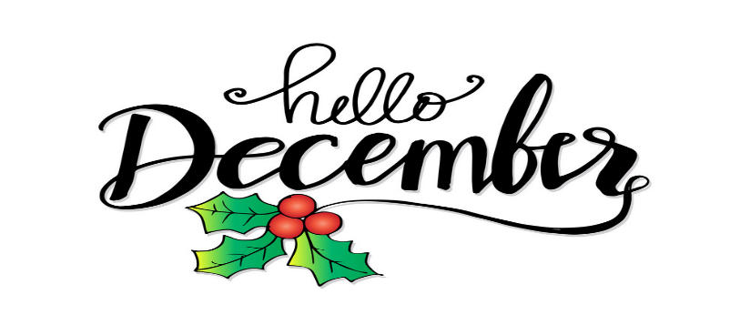 |  | 1  10:00 Ball Toss (G)  10:30 Flower Arranging (TW)  1:30 ShowTime (LIB)  2:30 Helping Hands (TW)  4:00 How Is It Spelled? (LIB)  6:30 Jeopardy (LIB) | 2  10:15 Groove and Move (LIB)  10:15 CATHOLIC CHURCH SERVICE (TW)  10:30 What’s Up In Rec? (W)  11:00 Trivia (LIB)  11:00 Shoeshine (W)  2:30 Crib Club (TW)  6:30 Around The Globe (TW) | 3  10:30 Painting (TW)  10:30 Java Music Club (LIB)  2:00 Balloon Badminton (TW)  2:30 News & Views (LIB) | 4  George B.  Bunny M.  Ed B.  Ed F.  Gail R.  Jenny D.  Mario S.  Bertha M.  Margaret I.  Ursula R.  Brigitte A.  Margaret H.  Hjordis B.  Lilian G.  Eileen M.  William K.
5  ROOM LEGEND  (B) BRITANNIA  (DR) DINING ROOM  (FL) FRONT LOUNGE  (FP) FRONT PATIO  (G) GLENMORE  (GC) GARDEN COURT  (H) HERITAGE  (LIB) LIBRARY  (R) RIDEAU  (TW) THERAPY WING  (W) WINGS | 6  11:00 Trivia (LIB)  11:00 Chair Yoga (TW)  1:45 Create and Construct –  Christmas Tree Decorations (TW)  2:00 Rhythm Band (LIB)  6:30 Bingo (TW) | 7  10:00 Sing With Me (LIB)  10:45 LUNCHBOX THEATRE OUTING  “ALL I WANT FOR CHRISTMAS” (TW)  3:00 Crib Club (TW) | 8  10:00 Ball Toss (H)  10:30 Flower Arranging (TW)  1:30 ShowTime (LIB)  2:30 Helping Hands (TW)  4:00 Bean Bag Toss (TW)  6:30 Jeopardy (LIB) | 9  10:15 CATHOLIC CHURCH SERVICE (TW)  10:30 Mindful Meditations (LIB)  2:00 Shuffleboard (TW)  2:00 Fabulous Nails (W)  6:30 Around The Globe (TW) | 10  10:00 Painting (TW)  10:30 Java Music Club (LIB)  2:00 Balloon Badminton (TW)  2:00 Nature Night (LIB) | 11

SUNDAY |  | MONDAY | TUESDAY | WEDNESDAY | THURSDAY | FRIDAY | SATURDAY
12 |  | 13  10:00 LIBRARY CART WITH PAM (W)  10:00 Bingo (TW)  10:30 Chair Yoga (LIB)  11:00 Good Ol’ Days (W)  2:15 CRAIG WEST ENTERTAINS (TW) | 14  10:30 Sing With Me (LIB)  11:45 A&W LUNCHEON (TW)  2:00 Fabulous Nails (W)  3:30 Crib Club (TW)  6:30 HERITAGE PARK CHRISTMAS CAROLLERS (W) | 15  10:15 Flower Arranging (TW)  10:30 Creative Movement (LIB)  2:30 Helping Hands (TW) | 16  10:00 Mindful Meditations (LIB)  10:15 CATHOLIC CHURCH SERVICE (TW)  2:00 Time Slips (LIB)  2:00 Heighten Your Senses (R)  6:30 Around The Globe (TW) | 17  10:30 Java Music Club (LIB)  2:00 Painting (TW) | 18
 | 19 | 20  9:45 RESIDENT & FAMILY COUNCIL MEETING (LIB)  11:00 Chair Yoga (LIB)  1:30 Bible Study (LIB)  2:15 Gingerbread House Making (TW)  6:30 Christmas Movie Night (TW) | 21  10:00 Brain Games (TW)  10:30 Christmas Sing With Me (LIB)  1:15 CHRISTMAS SHOPPING AT WALMART OUTING (TW)  2:30 Shuffleboard and  Ice Cream Treats (TW)  6:30 Time Slips (LIB) | 22  10:00 Ball Toss (R)  10:30 Flower Arranging (TW)  1:30 ShowTime (LIB)  2:30 Helping Hands (TW)  4:00 How Is It Spelled? (LIB)  6:30 Bingo (TW) | 23  10:15 CATHOLIC CHURCH SERVICE (TW)  1:30 CHRISTMAS PARTY ON THE WINGS (W)  (We will spend 30 minutes on each wing and will start on Glenmore, then go to Heritage, Britannia, and end with Rideau). | 24  10:00 Painting (TW)  10:30 Java Music Club (LIB)  2:30 CHRISTMAS  TEA PARTY CELEBRATION (TW) | 25
26 |  | 27  10:00 LIBRARY CART WITH PAM (W)  11:00 Mandala Coloring (TW)  1:45 Balloon Badminton (TW)  2:00 Music Appreciation (LIB)  3:45 Bible Study (LIB)  6:30 Bingo (TW) | 28  10:00 Brain Games (LIB)  11:00 Sing With Me (LIB)  1:30 News & Views (LIB)  2:00 Shuffleboard (TW)  3:30 Crib Club (TW)  4:00 Groove and Move (LIB)  6:30 Time Slips (LIB) | 29  10:00 Good Ol’ Days (W)  10:30 Flower Arranging (TW)  1:30 ShowTime (LIB)  2:30 Helping Hands (TW)  4:00 Bean Bag Toss (TW)  6:30 Jeopardy (LIB) | 30  9:30 Groove and Move (LIB)  10:15 CATHOLIC CHURCH SERVICE (TW)  10:30 Mindful Meditations (LIB)  10:45 ORIGINAL JOE’S LUNCH OUTING (TW)  2:00 Sing With Me (LIB)  3:30 Fabulous Nails (W)  6:30 Around The Globe (TW) | 31  10:30 Painting (TW)  10:30 Java Music Club (LIB)  2:15 BRINGING  IN THE NEW YEAR CELEBRATION  WITH ENTERTAINMENT  (TW)

