SUNDAY | MONDAY | TUESDAY | WEDNESDAY | THURSDAY | FRIDAY | SATURDAY
1  HELEN T.  WOODY O.  JUDE H.  THERESA L.  WILMA D.  MARION N.  SUZAN B.  RUTH H.  SHELIA S.  DORIS M. | 2  10:30 Ball Toss (TW)  1:45 Bingo (TW) | 3  10:00 Brain Games (LIB)  11:00 Groove and Move (H)  11:45 FIVE GUYS LUNCHEON (TW)  1:30 Chair Yoga (LIB)  2:15 Create and Construct (TW)  4:00 Mandala Coloring (TW)  6:30 Time Slips (LIB) | 4  10:15 Prayer Group (LIB)  10:30 Flower Arranging (TW)  11:00 Move To The Beat (LIB)  2:15 ENTERTAINMENT WITH ANNA & DAIGA (GC/TW)  6:30 Bingo (TW) | 5  10:00 Shuffleboard (TW)  1:30 Trivial Pursuit (LIB)  2:30 Bible Study (LIB) | 6  10:00 Creative Movement (TW)  10:30 Java Music Club (LIB)  2:00 Painting (TW) | 7  10:00 Shuffleboard (TW)  2:30 Sing With Me (LIB)
8  ROOM LEGEND  (B) BRITANNIA  (DR) DINING ROOM  (FL) FRONT LOUNGE  (FP) FRONT PATIO  (G) GLENMORE  (GC) GARDEN COURT  (H) HERITAGE  (LIB) LIBRARY  (R) RIDEAU  (TW) THERAPY WING  (W) WINGS | 9  10:30 Bean Bag Toss (TW)  1:45 Bingo (TW)  2:00 Walk & Talk (GC)  4:00 Lemonade and Music (LIB)  6:30 Movie Night (TW) | 10  9:00 HANDI-BOAT OUTING (TW)  10:00 Brain Games (LIB)  10:00 LIBRARY CART WITH PAM (W)  11:00 Groove and Move (H)  1:30 Chair Yoga (LIB)  2:15 ICE CREAM SOCIAL (TW) | 11  10:15 Prayer Group (LIB)  10:30 Flower Arranging (TW)  11:00 Ring Toss (TW)  1:30 Show Time (LIB)  4:00 Card Games (TW)  6:30 Bingo (TW) | 12  9:00 HANDI-BOAT OUTING (TW)  10:30 Edible Arrangements (TW)  4:00 Helping Hands (TW)  6:30 Around The Globe (TW) | 13  10:00 Creative Movement (TW)  10:30 Java Music Club (LIB)  2:00 Painting (TW) | 14  10:00 Card Bingo (TW)  2:30 Balloon Badminton (TW)

SUNDAY |  | MONDAY | TUESDAY | WEDNESDAY | THURSDAY | FRIDAY | SATURDAY
15  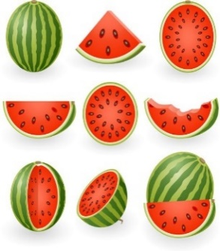 |  | 16  10:00 Bingo (TW)  4:00 Songs of Faith (LIB)  6:30 Movie Night  Documentary (TW) | 17  10:00 Sing With Me (LIB)  10:30 AUGUST SOCIAL (B)  (For Britannia Residents)  12:45 HORSE VISITS IN THE COUNTRY OUTING (TW)  1:30 Chair Yoga (LIB)  2:15 Brain Games (LIB)  4:00 Groove & Move (H)  4:00 Mandala Coloring (TW)  6:30 Time Slips (LIB) | 18  10:15 Prayer Group (LIB)  10:30 Flower Arranging (TW)  11:00 Move To The Beat (LIB)  1:30 Show Time (LIB)  4:00 Rhythm Band (LIB)  6:30 Bingo (TW) | 19  10:45 PICNIC AT WEASEL HEAD PARK OUTING (TW)  11:00 Ladder Ball (TW)  2:30 Walk & Talk (GC)  3:45 Bible Study (LIB)  4:00 Helping Hands (TW)  6:30 Nature Night (TW) | 20  10:00 Creative Movement (TW)  10:30 Java Music Club (LIB)  2:00 Painting (TW) | 21  10:00 Shuffleboard (TW)  2:30 Bean Bag Toss (TW)
 | 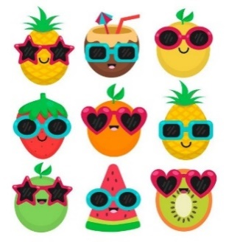  22 | 23  10:30 ERNA PLAYS CLASSICAL PIANO (TW)  1:45 Bingo (TW)  2:00 Walk & Talk (GC)  4:00 News & Views (LIB)  6:30 Shuffleboard (TW) | 24  10:00 Brain Games (LIB)  10:00 Sing With Me (H)  10:00 LIBRARY CART WITH PAM (W)  1:15 MY FAVOURITE ICE CREAM SHOPPE OUTING (TW)  2:15 Create & Construct (TW)  4:00 Bible Study (LIB)  6:30 Time Slips (LIB) | 25  10:15 Prayer Group (LIB)  10:30 Flower Arranging (TW)  11:00 Ring Toss (TW)  1:30 Show Time (LIB)  4:00 Card Games (TW)  6:30 Jeopardy (TW) | 26  10:15 Let’s Chat (R)  10:30 Edible Arrangements (TW)  12:45 HORSE VISITS IN THE COUNTRY OUTING (TW)  1:45 Bingo (TW) | 27  10:00 Creative Movement (TW)  10:30 Java Music Club (LIB)  2:00 Painting (TW) | 28  10:00 Shuffleboard (TW)  2:30 Sing With Me (LIB)
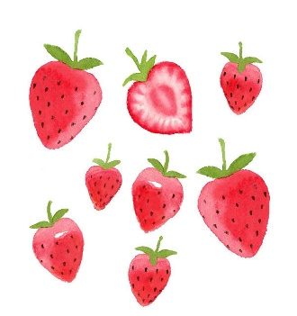  29 |  | 30  9:45 RESIDENT & FAMILY COUNCIL MEETING (LIB)  2:30 ELVIS IS IN THE BUILDING (GC/DR)  6:30 Shuffleboard (TW) | 31  10:00 Brain Games (LIB)  10:45 PICNIC AT EDWORTHY PARK OUTING (TW)  11:00 Groove and Move (H)  1:30 Chair Yoga (LIB)  2:15 Cornhole/Ring Toss & Watermelon (TW)  4:00 Mandala Coloring (TW)  6:30 Time Slips (LIB)

